Name: Rushiraj Suwarnkar  
Roll no.: 381018  
PRN: 22310315  
———————————————————————————————

**Assignment 7: Implement Forward Chaining Algorithm**  
———————————————————————————————

**Problem Statement:**  
Implement the Forward Chaining algorithm to infer conclusions from a given knowledge base consisting of facts and rules. The system should iteratively apply rules to derive new facts until a goal is reached.  
———————————————————————————————

**Objectives:**

* Understand the concept of Forward Chaining in inference systems.
* Implement Forward Chaining for knowledge-based problem solving.
* Apply Forward Chaining to infer new facts from existing knowledge.  
  ———————————————————————————————

**Theory:**  
———————————————————————————————

**Methodology:**  
Forward Chaining is a data-driven inference technique used in expert systems. It starts with known facts and applies inference rules to derive new facts until the goal or conclusion is reached. The algorithm is iterative and adds newly inferred facts to the knowledge base to trigger further rules.  
———————————————————————————————

**Working Principle / Algorithm:**  
———————————————————————————————

**Forward Chaining Algorithm:**

1. Initialize the knowledge base with known facts.
2. Identify all rules whose conditions (antecedents) are satisfied by the current facts.
3. Apply applicable rules to infer new facts.
4. Add newly inferred facts to the knowledge base.
5. Repeat steps 2–4 until the goal fact is inferred or no new facts can be added.
6. Output the derived facts or confirm if the goal is reached.  
   ———————————————————————————————

**Advantages:**

* Efficient for problems with a large set of initial facts.
* Automatically derives all possible conclusions from the knowledge base.
* Suitable for expert systems and rule-based reasoning.  
  ———————————————————————————————

**Disadvantages / Limitations:**

* May generate unnecessary facts if the goal is specific.
* Can be inefficient for very large knowledge bases.
* Only works in a forward, data-driven manner; cannot reason backward from goals.  
  ———————————————————————————————

**Diagram:**

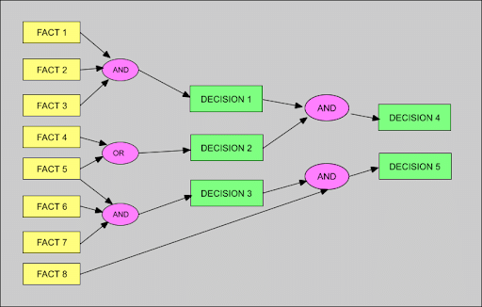  
———————————————————————————————

**Conclusion:**  
Forward Chaining is a fundamental inference mechanism in knowledge-based systems. By starting from known facts and applying rules iteratively, it effectively derives new knowledge and supports automated decision-making in expert systems.  
———————————————————————————————